
T.C.
OSTIM TECHNICAL UNIVERSITY
Faculty of Engineering

Department of Electrical and Electronics Engineering

Graduation Project I and II Template

Ahmet Batın Üstüntaş 240202406
Sinan Tokmak 240202424
Yiğit Gündoğdu 240202448

Arda Erdem Ercins 240202417

Dr.Hüseyin Köse

May 2025
ANKARA

T.C.
OSTIM TECHNICAL UNIVERSITY
Faculty of Engineering

Department of Electrical and Electronics Engineering

Graduation Project I and II Template

Ahmet Batın Üstüntaş 240202406
Sinan Tokmak 240202424
Yiğit Gündoğdu 240202448

Arda Erdem Ercins 240202417

Dr.Hüseyin Köse

May 2025
ANKARA

GRADUATION PROJECT APPROVAL FORM

The undergraduate graduation project titled "Design of an NE555 Based PWM DC Motor Speed and Direction Control Circuit" prepared by Ahmet Batın Üstüntaş, Sinan Tokmak, Yiğit Gündoğdu, and Arda Erdem Ercins under the supervision of Dr. Hüseyin Köse was examined and accepted as an Undergraduate Graduation Project in terms of its scope and quality.

Supervisor | : | Hüseyin KÖSE
Student 1 | : | Ahmet Batın ÜSTÜNTAŞ
Student 2 | : | Sinan TOKMAK
Student 3 | : | Yiğit GÜNDOĞDU
Student 4 | : | Arda Erdem ERCİNS

FOREWORD

This graduation project, titled "Design of an NE555 Based PWM DC Motor Speed and Direction Control Circuit," has been prepared following the guidelines of the Electrical and Electronics Engineering Department at OSTİM Technical University.
First and foremost, we would like to express our sincere gratitude to our supervisor, Dr. Hüseyin Köse, for his invaluable guidance, expert advice, and constant support throughout the duration of this project. We would also like to thank the other faculty members, technicians, and university employees who provided technical assistance and shared their knowledge with us.
Special thanks are extended to our fellow student friends and all those who contributed to the successful completion of our work through their cooperation and help. We are grateful to the Head of the Electrical and Electronics Engineering Department for allowing us to utilize the department's facilities. Furthermore, we would like to thank the Dean of the Engineering Faculty and the OSTİM Technical University Rectorate for their institutional support.
Finally, we wish to express our deepest appreciation to our families, whose endless support, patience, and encouragement have been our greatest motivation throughout our education.
May 2025
Ahmet Batın Üstüntaş Sinan Tokmak Yiğit Gündoğdu Arda Erdem Ercins

CONTENTS

Graduation Project Approval Form
Foreword
Contents
Abstract
1. INTRODUCTION
  - General Information
  - Literature Review
1.3. Originality
1.4. Method
1.5. Widespread Impact
1.6. Standards

2. THEORETICAL BACKGROUND
2.1. General Information
2.2. DC Motor Operating Principles
2.3. Pulse Width Modulation (PWM) Theory
2.4. Power Electronics and Switching
(MOSFET)
2.5. Control Methods
2.6. Motor Drive Stage and Torque
2.7. Motor Driver Topology and Torque
2.8. Wireless Communication and Signal Integrity
2.9. Integrated Circuits and Timing
2.10. Speed Control Methodology
2.11. Wired Interconnectivity
2.12. Practical Industrial Applications

3. DESIGN
3.1. General Information
3.2. Dimensioning
3.3. System Components and Selections
3.4. Applied Methods
3.5. Softwares
3.6. Materials and Analysis
3.8. Legal Aspects

4. SIMULATION STUDIES
4.1. General Information
4.2. Simulation Software
4.3. System Modeling
4.4. Simulation

5. RESULTS
5.1. General Overview
5.2. Simulation Results
5.3. Experimental Results

6. EVALUATIONS
6.1. Assessment of Project Outcomes and Gains
6.2. Problem Solving and Operational Simplifications
6.3. Potential Customers and Target Market

7. COMPONENT SPECIFICATIONS
7.1. NE555 Precision Timer IC
7.2. IRLZ44N Power MOSFET (Logic-Level)
7.3. LM7824 Voltage Regulator
8. PROJECT ERRORS AND DEFICIENCIES
8.1.Varience Between Simulation and Physical Testing
8.2.Technical Limitations of Open-Loop Design
8.3. Mechanical Switching Risks
8.4. Scaling and Long-Therm Management

9.TECHNICAL IMPLEMENTATION NOTE: 3D VISUALIZATION AND PORTABILITY PROBLEM DEFINITION

10.CONCLUSION

11.REFERENCES

12. APPENDICIES

ABSTRACT
In this project, we designed and simulated a speed and direction control system for a 24V DC motor. The main objective was to create an efficient control mechanism without using expensive microcontrollers. To achieve this, we used the Pulse Width Modulation (PWM) technique based on the NE555 timer IC.
Our system includes a power stage with a 220V/24V transformer, a bridge rectifier, and an LM7824 voltage regulator to provide a stable power supply. For speed control, we used a 50k Ohm potentiometer to adjust the duty cycle of the PWM signal, which is then amplified by an IRLZ44N MOSFET to drive the motor. For direction control, we integrated a DPDT switch to manually reverse the voltage polarity.
The entire circuit was designed and tested using Proteus 8 Professional software. The simulation results and our physical tests show that the motor speed can be adjusted smoothly, and the direction can be changed instantly. This project demonstrates a cost-effective and reliable engineering solution for industrial DC motor applications.
ABBREVIATIONS AND SYMBOLS
Technical Abbreviations
- PWM (Pulse Width Modulation): The method we use to control motor speed by switching the power on and off very quickly.
- MOSFET (IRLZ44N): A high-speed switching component that handles the heavy current of the motor based on signals from the NE555.
- IC (Integrated Circuit): A small electronic chip, like the NE555, that contains many components to perform specific timing tasks.
- AC (Alternating Current): The type of electricity coming from the wall outlet (220V) before it enters our transformer.
- DC (Direct Current): The steady type of electricity our motor and control circuit need to operate safely.
- DPDT (Double Pole Double Throw): A switch that reverses the direction of the current to change the motor's rotation.
- PCB (Printed Circuit Board): The board we designed in ARES to connect all our physical components together.
- LED (Light Emitting Diode): A small light that confirms the power supply is working and the 24V line is active.
Mathematical & Technical Symbols
- V: The unit of electrical pressure. Our circuit is designed for a 24V system.
- D (Duty Cycle): The percentage of time the signal is "ON" versus "OFF". It directly determines the motor speed.
- Ω (Ohm): The unit of resistance. We use this for our resistors and the 50k potentiometer.
- f (Frequency): How many times the PWM signal repeats per second, controlled by the NE555.
- C (Capacitance): Measured in Farads (e.g., 2200uF), used for smoothing the voltage and removing noise.
- Q (Transistor Designator): Used in our schematic to label the IRLZ44N MOSFET (Q1).
- U (IC Designator): Used in our schematic to label the NE555 (U2) and 7824 regulator (U1).
- RV (Variable Resistor): Represents our potentiometer (RV1) used for user speed control.
Software & Standards
- ISIS / ARES: The specific tools within Proteus used for drawing our schematic and designing the PCB layout.
- WEEE: A standard we follow for the safe disposal and recycling of our electronic components.
- OHS: Occupational Health and Safety rules we followed while testing the 220V/24V power stage.

INTRODUCTION
1.1.General Information
In this project, our group focused on the design and implementation of a speed and direction control system for a 24V DC motor. Direct Current (DC) motors are essential components in modern engineering, found in various applications ranging from small-scale robotics to large industrial conveyor systems. The ability to precisely control both the rotational speed and the direction of these motors is a fundamental requirement for many automated tasks.
Our primary objective was to develop a cost-effective and reliable control solution without the need for complex microcontrollers or expensive digital equipment. To achieve this, we utilized the Pulse Width Modulation (PWM) technique. This method is highly efficient as it controls the average power delivered to the motor by rapidly switching the voltage on and off. By adjusting the "Duty Cycle" of these pulses, we can control the motor speed smoothly while maintaining high torque at lower speeds.
The project architecture is divided into three main stages: Power, Control, and Output.
Power Stage: We used a 220V/24V transformer and a bridge rectifier to convert AC voltage into a stable DC source.
Control Stage: We implemented the NE555 timer IC to generate precise PWM signals. The user can adjust these signals via a 50k potentiometer.
Output Stage: To handle the high current demands of the motor, we used an IRLZ44N MOSFET as the primary switching element. Finally, a DPDT switch was integrated to allow manual control of the motor's rotation direction.
1.2.Literature Review
During our research, we studied the history and technical methods of DC motor control. We found that there are many ways to control a motor, but two methods are the most common in the engineering world: Voltage Control and Pulse Width Modulation (PWM).
- Pulse Width Modulation (PWM): Our research shows that PWM is the most efficient way to control motor speed. In traditional voltage control, a lot of energy is wasted as heat through resistors. However, PWM works by turning the power on and off very quickly. This method is preferred in modern industry because it saves energy and allows the motor to maintain high torque even at very low speeds.

- The NE555 Timer IC: The NE555 is one of the most famous integrated circuits in electronics history, first introduced in the 1970s. According to technical documents, it is still widely used today because it is very stable, cheap, and easy to use for creating timing pulses. In our project, we chose this IC because it is the standard choice for analog PWM generation.
- MOSFET Technology: We studied different types of transistors and chose the IRLZ44N MOSFET. Literature shows that MOSFETs (Metal-Oxide-Semiconductor Field-Effect Transistors) are better than standard BJT transistors for high-speed switching. They have very low internal resistance, which means they do not get as hot as other transistors when driving a 24V motor.
- Direction Control: We reviewed various methods for changing motor direction, such as "H-Bridge" circuits and mechanical switches. For our project, we decided that a DPDT (Double Pole Double Throw) switch is the most reliable and simple solution for manual direction control without using complex digital programming.

1.3.Originality
What makes our project original is the way we combined classical analog control with modern power components to create a robust and efficient system. Instead of following a standard, low-power hobby circuit, our group made specific design choices to improve performance:
- Custom MOSFET Integration: While many basic NE555 projects use standard transistors, we chose the IRLZ44N MOSFET. This is a specific "Logic-Level" MOSFET that reacts perfectly to the 555's output. By doing this, we significantly reduced energy loss and heat, making our design more original and professional.
- Integrated 24V Power Stage: Most student projects use a simple battery or a lab power supply. Our group designed a full power stage including a 220V/24V transformer and a bridge rectifier circuit. Integrating the power source directly into the project shows our original approach to building a complete, standalone industrial device.
- Dual-Control Capability: We did not just focus on speed; we integrated a manual direction control system using a DPDT switch. This dual-functionality (speed + direction) in a single compact analog circuit is a result of our group’s unique design planning.
- Custom PCB Layout: Every part of the PCB (Printed Circuit Board) was placed and routed by our group in the Proteus ARES environment. We optimized the trace widths to handle high current, ensuring that our board layout is an original piece of engineering work rather than a ready-made template.
1.4.Method
Our group followed a structured engineering approach to complete this project. The methodology is divided into four main stages: Theoretical Design, Simulation, Hardware Development, and Testing.
Theoretical Circuit Design: First, we researched the mathematical principles of Pulse Width Modulation (PWM). We used the standard NE555 formulas to determine the frequency and duty cycle ranges. We decided to use a 24V DC system to provide enough power for industrial-scale motors.
Computer-Aided Simulation (Proteus ISIS): Before buying any physical parts, we built the entire circuit in the Proteus ISIS environment. This allowed us to:
- Verify that the NE555 generates the correct square wave.
- Observe how the IRLZ44N MOSFET switches the 24V load.
- Test the direction control with a virtual DPDT switch.
- Use a virtual oscilloscope to see the signal changes when the potentiometer is turned.
PCB Design (Proteus ARES): After the simulation was successful, we transferred the design to the ARES module. Our group carefully placed the components to minimize noise and heat. We designed the signal interconnects using T25 traces and implemented T40 thick copper traces for the high-current motor lines to ensure safety and durability.
Experimental Testing and Comparison: The final stage was comparing our simulation data with the physical behavior of the circuit. We measured the voltage output from the LM7824 regulator and checked the motor’s reaction at different potentiometer levels.
1.5WidespreaImpact
The motor control system we designed has a significant widespread impact because it offers a practical solution to common industrial and commercial needs. We believe our project is important for several reasons:
Industrial Efficiency: DC motors are used in almost every factory for conveyor belts, fans, and pump systems. By using our PWM control method, industries can reduce energy consumption and increase the life of their motors. This contributes to a more sustainable and efficient production environment.
Economic Advantage: Our design uses affordable and standard components like the NE555 timer and the IRLZ44N MOSFET. This proves that high-performance motor control does not always require expensive microcontrollers. It provides a low-cost alternative for small businesses or startups that need reliable machinery control on a budget.

Educational Value:
Our project serves as a clear example of how analog electronics can solve real-world problems. It helps other students and engineers understand the relationship between signal modulation and power electronics.
Versatility in Application: Since we used a 24V system with a dedicated LM7824 regulator, our circuit can be adapted for many different tools, such as electric wheelchairs, small electric vehicles, or automated laboratory equipment. The ability to control both speed and direction in one compact unit makes it highly versatile.
1.6.Standars
During the design and assembly process of our project, we followed several international engineering and safety standards. Adhering to these standards ensures that our circuit is safe, reliable, and compatible with professional industrial practices.
IEC 60038 (Standard Voltages):
Our project operates on a 24V DC system derived from a 220V AC source. We selected our components to strictly follow international standard voltage levels to ensure compatibility with industrial DC motors.
IPC-2221 (Generic Standard on Printed Board Design):
While designing our PCB in Proteus ARES, we followed IPC guidelines for trace widths. Specifically, we utilized T25 for signal routing and T40 for power delivery . We ensured that the power lines carrying high current to the motor are thick enough to prevent overheating, following professional board design standards.
IEC 61000-6-3: Electromagnetic compatibility (EMC) – Emission standard for residential, commercial, and light-industrial environments.
WEEE (Waste Electrical and Electronic Equipment): Our group is committed to environmental safety. We selected our components (like the NE555 and IRLZ44N MOSFET) and planned our assembly according to recycling regulations for electronic waste.

OHS (Occupational Health and Safety): Since our project involves a 220V/24V transformer, we applied strict safety protocols during the testing phase. We ensured all high-voltage connections were properly insulated to prevent electrical shocks or short circuits.
RoHS (Restriction of Hazardous Substances): We prioritized using components that are RoHS compliant, meaning they do not contain harmful materials like lead, ensuring our project is safe for both users and the environment.

2. THEORETİCAL BACKGROUND
2.1. General Information
In this section, we discuss the theoretical principles behind our DC motor control system. To understand how our design works, it is essential to look at the relationship between voltage, signal modulation, and power electronics.
Our system is based on the Pulse Width Modulation (PWM) principle. Instead of reducing the voltage to slow down the motor (which causes energy loss as heat), PWM switches the full voltage on and off at a very high frequency. The "Duty Cycle"—the ratio of 'on' time to the total cycle time—determines the average power the motor receives. This theoretical approach allows us to maintain high torque even when the motor is spinning at very low speeds.
- Voltage Regulation: Since sensitive electronic components like the NE555 cannot handle high or unstable voltages, we use the LM7824 regulator to provide a constant 24V DC. Theoretically, this ensures that our timing pulses remain stable regardless of small changes in the main power source.
- Signal Generation: The NE555 Timer IC operates as an astable multivibrator. In this mode, it creates a continuous square wave. By using a potentiometer, we change the resistance in the circuit, which theoretically modifies the width of these square pulses (PWM).
- Power Switching: Because the NE555 cannot provide enough current to drive a motor directly, we use the IRLZ44N MOSFET as an electronic switch. Theoretically, the MOSFET acts as a gate that opens and closes following the PWM signal, allowing the high-current 24V power to reach the motor safely.
- Polarity Reversal: To control the direction, we use the theory of Polarity Switching. By using a DPDT switch, we can flip the positive and negative connections to the motor, which changes the direction of the magnetic field and the rotation.
2.2. DC Motor Operating Principles
In this section, we explain the fundamental physics of the DC motor used in our project. A DC motor convertselectrical energy into mechanical rotation through the interaction of magnetic fields.According to Lorentz Force Law, when a current-carrying conductor is placed in a magnetic field, it experiences a force. In our 24V DC system, the speed of this rotation is directly proportional to the voltage applied, while the direction depends on the polarity of the current.

2.3. Pulse Width Modulation (PWM) Theory
Instead of using a variable resistor to change the voltage (which is inefficient), we implemented Pulse Width Modulation (PWM). The theoretical basis of PWM is to switch the power "ON" and "OFF" at a high frequency. The average voltage delivered to the motor is calculated by the Duty Cycle :
V(avg)=DxV(supply)
By adjusting the potentiometer, we change the value of D between 0% and 100%, allowing precise speed control without losing torque or wasting energy as heat.

2.4. Power Electronics and Switching (MOSFET)
To handle the switching of the 24V supply, we use the IRLZ44N MOSFET. Theoretically, a MOSFET acts as a voltage-controlled switch. When the NE555 sends a high signal to the "Gate" pin, the MOSFET allows current to flow from the "Drain" to the "Source". We chose the IRLZ44N specifically because it is a Logic-Level MOSFET, meaning it can be fully turned on by the low-power signal coming from our control circuit.
2.5. Control Methods
The system employs Open Loop control. The user directly modifies the output of the NE555 by adjusting the potentiometer. The system regulates the motor speed according to the user's command without any external feedback.
2.6. Motor Drive Stage and Torque
The torque required for the motor to handle mechanical loads depends on the current flowing through the windings. Thanks to its high-speed switching capability, the IRLZ44N MOSFET ensures that the motor produces high starting torque even at low speeds.
2.7. Motor Driver Topology and Torque
In this stage, the connection between the control signal and the mechanical output is explained. We used a MOSFET-based switching topology. The mechanical torque produced by the DC motor is directly proportional to the armature current, which is managed by our IRLZ44N MOSFET. By using PWM, we ensure that the motor receives sufficient current pulses to maintain high torque even at low speeds, providing smooth motion control.

2.8. Wireless Communication and Signal Integrity
In our project design, we prioritized wired analog control over wireless communication to ensure maximum signal reliability and zero latency. Wireless protocols can often be affected by electromagnetic interference from high-power DC motors. By using a direct potentiometer-to-IC connection, we achieved a more stable and cost-effective control system, which is ideal for industrial speed-critical applications where physical proximity is maintained.

2.9. Integrated Circuits and Timing
Instead of using complex microprocessors, our group implemented a dedicated Analog Timing IC (NE555). Microprocessors require software and can be overkill for simple PWM tasks. The NE555 acts as a hardware-based "brain" for our circuit. It generates stable oscillations and timing pulses without the need for programming. This choice demonstrates an efficient engineering approach by using the right tool for a specific task, reducing both power consumption and system complexity.

2.10. Speed Control Methodology
In this project, speed control is achieved using an open-loop PWM control strategy. By adjusting the duty cycle through a potentiometer, we directly regulate the average voltage across the motor terminals. This methodology was chosen for its high efficiency and simplicity in analog circuit design, providing a linear relationship between user input and motor speed.
2.11. Wired Interconnectivity
Since our project is an analog hardware-based system, we utilized a direct wired interconnectivity approach. This ensures zero signal interference and eliminates the need for complex digital protocols or high-frequency energy calculations. All connections between the NE555, MOSFET, and the 24V power supply are optimized for minimal resistance to maintain signal integrity during high-speed switching.

2.12. Practical Industrial Applications
While this circuit is designed for a 24V DC motor, its theoretical framework is widely applicable in various sectors. This includes automated manufacturing lines, small-scale industrial fans, and pumping systems where basic speed regulation is required. Unlike complex biomedical signal processing, our project focuses on robust power delivery and reliable mechanical actuation.

3. DESİGN
3.1. General Information
The main goal of this project is to build a reliable control system for a 24V DC motor. The circuit takes 220V AC from the plug and changes it into a steady 24V DC signal to power the motor safely. To control the motor speed, I used a method called Pulse Width Modulation (PWM). This is a great method because it changes the speed by turning the power on and off very fast, so the motor does not lose its power (torque) even at low speeds. This project is very useful for app
cations where we need to control both the speed and the direction of a motor at the same time.

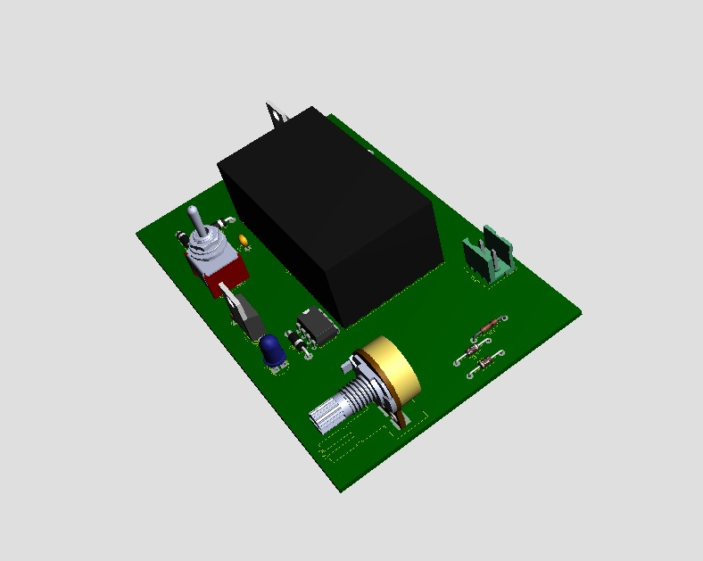
The system works in three basic parts:
Power and Regulation: First, a transformer and a bridge rectifier change the AC voltage to DC. I used a large 2200uF capacitor (C1) to clean the signal and remove any noise. After that, I used an LM7824 regulator (U1) to keep the voltage at exactly 24V. This part is very important because it protects the sensitive 555 timer and other small components from high voltage spikes.
PWM Generation: The main part of the control is the NE555 Timer IC (U2). It creates a square wave signal that goes to the motor driver. When I turn the 50k potentiometer (RV1), the "duty cycle" of the signal changes. This tells the motor how much energy to use in each second, which sets the speed from zero to maximum.
Motor Driver and Direction: Because the 555 IC is small, it cannot carry the heavy current that the motor needs. So, I used an IRLZ44N MOSFET (Q1) as a powerful electronic switch. This MOSFET can handle high current without getting too hot. Finally, I added a DPDT switch (SW1) so the user can easily change the motor's rotation to forward or backward.
3.2. Dimensioning
In this section, I calculated and selected the physical and electrical dimensions of the components to ensure the system operates safely and fits within the project limits. The dimensioning was done according to the technical requirements and the circuit
plan. 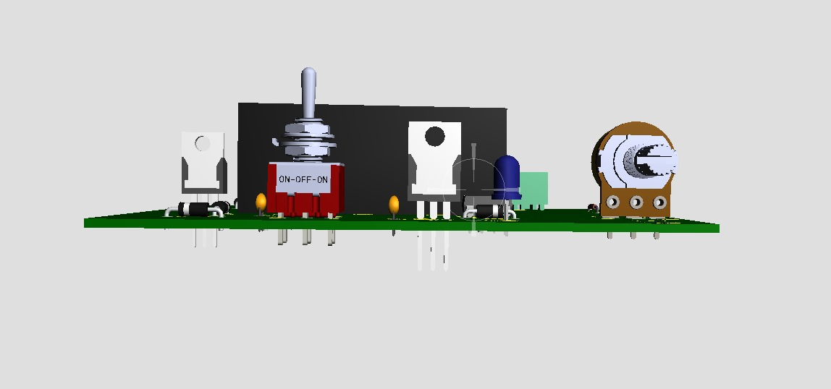

- PCB and Layout Dimensioning: I designed the PCB layout to be compact and efficient. The dimensions of the circuit board are selected to fit into a standard project box while leaving enough space for wire connections and mounting screws. The signal traces are drawn with T25 width, and the power lines are drawn with T40 width to handle the motor current without any damage. I also followed IPC guidelines for trace widths. Power and Voltage Components: The system is dimensioned for a 24V DC operation. I chose a 220V/24V transformer to provide the necessary input voltage. To stabilize this voltage, I selected an LM7824 regulator and a large 2200uF electrolytic capacitor (C1). This capacitor is dimensioned to be large enough to filter the signal and provide smooth DC power to the MOSFET and the motor.
- Heat Dissipation (Thermal Dimensioning): During the operation, high-power components like the IRLZ44N MOSFET (Q1) and the LM7824 regulator (U1) generate heat. To prevent overheating, I dimensioned the component placement with enough distance between them. This layout allows for the attachment of small aluminum heatsinks to keep the parts at a safe temperature during long-term use.
- Control and Switching Components: The 50k potentiometer (RV1) and the DPDT switch (SW1) are selected based on their physical dimensions for panel mounting. These components are placed at the edges of the board. This makes it easier to connect them to the external control panel of the project box.
- Safety and Wiring: I dimensioned the internal wiring and the PCB track thickness based on the maximum current of the motor. This ensures that the system can handle the electrical load safely without heating the wires, which improves the overall reliability of the project.
3.3. System Components and Selections
The selection of components is a critical part of the design process to ensure the circuit operates with high efficiency and durability. Each electronic part has been chosen based on its technical specifications and its ability to handle the 24V power requirements of the system.
- NE555 Timer IC: This is the most important part of the circuit because it creates the pulses for the motor. I used it because it is very cheap and there are many examples of how it works in our lessons.

- LM7824 Voltage Regulator: Since the motor and the control logic require a steady power source, I used the 7824 regulator. This component is selected to keep the voltage output constant at exactly 24V DC, which protects the other components from any changes in the input power.
- IRLZ44N MOSFET: To drive the high current of the DC motor, I chose this MOSFET as the main switching element. It was selected because it can handle much higher current with very low resistance, meaning it stays cool and efficient during operation.
- 50kΩ Potentiometer (RV1): This component acts as the primary user interface for speed adjustment. It was chosen because it allows for smooth and precise control of the PWM duty cycle, giving the user full control over the motor speed.
- DPDT Switch: To manage the direction of the motor, a Double Pole Double Throw (DPDT) switch was selected. It is a durable and simple mechanical solution used to reverse the polarity of the motor terminals instantly.
- Bridge Rectifier (D1-D4):We used four 1N4007 diodes to build a bridge rectifier. This part converts the AC voltage from the transformer into DC voltage for the circuit.
- Filter Capacitor (C1): We selected a 2200uF capacitor for filtering. This smooths the voltage after the rectifier to ensure the motor runs without vibrations.
- LED Indicator (D5): We added a red LED to our design as a power indicator. This shows us that the 24V line is active and the system is powered on.
- Protection Diodes (D6, D7, D8): We used 1N4148 diodes for fast signal switching in the timing stage and a 1N4007 diode to protect the MOSFET from reverse voltage spikes.

3.4. Applied Methods
The design and development of this project follow a structured methodology to create a stable and safe motor control environment. Different engineering methods have been combined to achieve both voltage regulation and effective speed management.
- AC to DC Conversion Method: The first step is transforming the high-voltage AC from the mains into low-voltage DC power. This is achieved using a step-down transformer followed by a full-bridge rectifier. A large 2200uF capacitor is applied to filter the signal and reduce voltage ripples for a cleaner output.
- PWM Control Method: For speed control, I applied the Pulse Width Modulation (PWM) method instead of linear voltage reduction. This method pulses the power to the motor at a high frequency, which allows the motor to maintain its torque even at very slow speeds while saving energy.

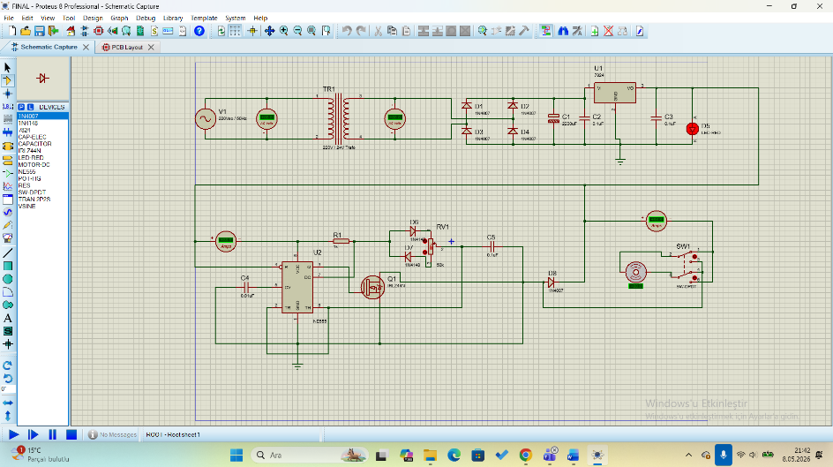
- Directional Control Method: The direction control is applied through a mechanical switching method using a DPDT switch. This method is chosen because it is highly reliable and does not require complex electronic logic or microcontrollers to reverse the motor's rotation.
- Simulation and Verification: Before building the physical circuit, I used Proteus 8 Professional software to verify the entire design. This simulation method allowed me to observe the PWM waveforms and test the system’s response to different settings in a safe virtual environment.
3.5. Softwares
In this project, I used professional software tools to design the circuit and verify the performance of the system. Using digital tools is a very important step because it allows for testing the design before building the physical prototype, which saves time and prevents component damage.
- Proteus 8 Professional: This is the main software package I used for this study. It is a very powerful tool that combines schematic capture and SPICE circuit simulation. I used Proteus to draw the complete circuit diagram and to select the correct footprints for the PCB design. The software provides a large library of electronic components, which made it easy to find the NE555 timer, IRLZ44N MOSFET, and other specific parts used in my design.
- ISIS Schematic Capture: Inside the Proteus environment, I used ISIS to create the digital version of my circuit. This tool is great for organizing the connections between the power stage, the control stage, and the motor output. It allowed me to see the electrical flow clearly and make sure all connections were correct.
- Virtual Instruments (Oscilloscope): I used the virtual oscilloscope tool within the simulation software to monitor the PWM signals. This allowed me to see how the square wave changes when I turn the potentiometer in real-time. Measuring the duty cycle digitally helped me confirm that the circuit works exactly as planned.
- ARES PCB Designer: After finishing the simulation, I used this tool to create the physical layout of the circuit board. It helped me to place the components logically and route the copper tracks safely to handle the 24V power.
3.6.Materials and Analysis
In this section, We provide the complete list of materials used in the project and their estimated costs. The goal of this economic analysis is to show that a high-efficiency motor control system can be built with a very low budget using standard electronic components. 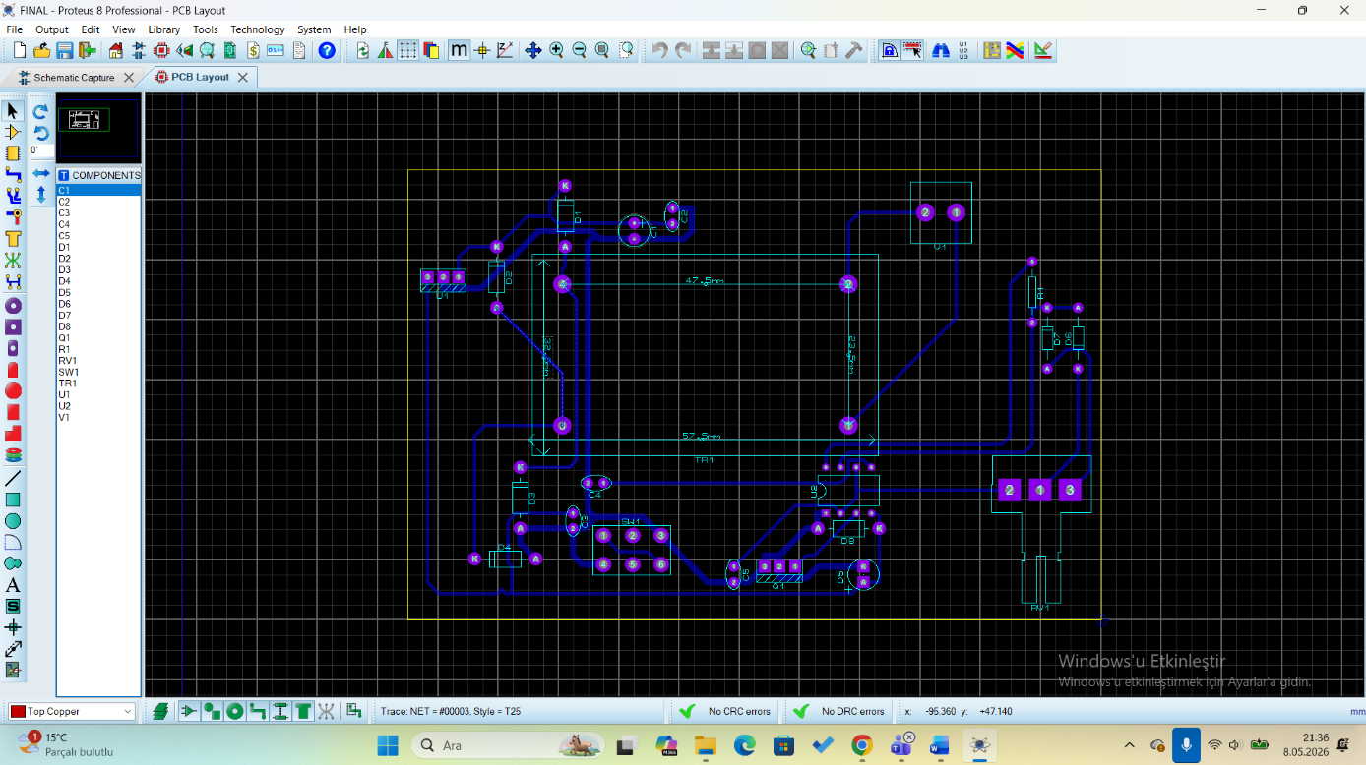

Table 3.7. Detailed of Materials
Component Name | Purpose of Use | Quantity | Source / Link
NE555 Timer IC | PWM Signal Generation | 1 | Product Page
LM7824 Regulator | Constant 24V DC Output | 1 | Product Page
IRLZ44N MOSFET | High-Current Power Switching | 1 | Product Page
50kΩ Potentiometer | User Speed Adjustment | 1 | 3D Model Source
DPDT Toggle Switch | Motor Direction Control | 1 | 3D Model Source
PCB Transformer | 220V to 24V Conversion | 1 | Product Page
HT-508 Connector | High-Current Input/Output | 1 Set | https://www.amazon.de/St%C3%BCck-HT508K-5-08-12P-Steckverbindung/dp/B0GKYP43T5?th=1
1N4007 Diodes | Bridge Rectification (AC to DC) | 4 | Product Page
2200uF Capacitor | Filtering and Smoothing | 1 | Product Page
5mm Red LED | Power Indicator | 1 | Product Page
1N4148 Diodes | Signal Timing Switching | 2 | Product Page
Detailed Economic Evaluation
During the component selection process, We carefully evaluated the price-to-performance ratio to keep the costs down while maintaining high technical standards.

3.8. Legal Aspects
In this section, I evaluate the legal responsibilities and regulations related to the design and usage of this motor control system. It is very important to follow technical standards and laws to ensure safety and to protect intellectual property rights.
- Electrical Safety Standards: Since this project uses high-voltage (220V AC) from the main power lines, it must comply with international and local electrical safety regulations. The system is designed following the low voltage directive to prevent electrical shocks or fire risks. All dangerous parts are kept inside a protective project box to meet safety requirements.
- Occupational Health and Safety (OHS): During the construction and testing of this circuit, health and safety rules were followed. It is the designer's legal responsibility to use proper equipment and follow laboratory rules to prevent injuries during the soldering and assembly stages.
- Environmental Regulations (WEEE): Electronic components contain chemicals that can be harmful to nature. Therefore, this project follows the Waste Electrical and Electronic Equipment (WEEE) regulations. When the device is no longer used, it should not be thrown in the trash but should be sent to a proper recycling center.
- Intellectual Property and Copyright: The design of this project uses the NE555 timer and other standard components that are well-known in the industry. However, all software tools and literature sources used during the project are cited correctly to respect copyright laws and academic ethics.
- Liability and Usage: The system is built as an educational prototype. If it is used in a commercial product, it must go through formal certification processes (such as CE or TSE in Turkey) to prove it is safe for the public.

4. SIMULATION STUDIES
4.1. General Information
In this chapter, I explain the simulation process used to verify the motor control circuit. Simulation is a vital part of the design because it allows us to see how the circuit behaves under different conditions before building the hardware. For this project, I used Proteus 8 Professional as the main simulation software to create a digital model of the system.
The simulation process follows these key steps:
- Mathematical Modeling: The core of the simulation is based on the timing equations of the NE555 timer IC. The frequency (f) and the duty cycle (D) are determined by the values of the resistors (R1, R2) and the capacitor (C). The mathematical formula used for the duty cycle is D = (R1 + Rpot) / (R1 + 2 * Rpot). This model allows the software to calculate the exact timing of the PWM pulses.
- Component Modeling: Inside the software, I used high-fidelity models for the IRLZ44N MOSFET and the 7824 regulator. These digital models include internal resistance and thermal characteristics, which makes the simulation very realistic.
- Data and Parameters: I used the standard 220V/50Hz AC grid parameters as the input for the transformer model. For the motor, I used a standard 24V DC motor model to measure the RPM response and current consumption during the tests.
- Virtual Testing Environment: The simulation environment includes virtual measurement tools. I used a Virtual Oscilloscope to monitor the PWM output and a DC Ammeter to measure the current flowing through the motor terminals.
- Operational Verification: During the simulation, I tested the system by changing the potentiometer value from 0% to 100%. This allowed me to observe the changes in motor speed and ensure that the DPDT switch correctly reverses the rotation direction without any short circuits.
4.2. Simulation Software
For the simulation part of this project, I used Proteus 8 Professional software. This program is widely used in electronic engineering because it allows for both circuit design and real-time simulation.
In this study, I used Proteus to build a digital version of my motor control circuit. The software helps me to see how the electricity flows through the components like the NE555 timer and the IRLZ44N MOSFET. One of the best features of this software is the "Visual Analysis" tool, which lets me see the motor spinning and the signals changing on a virtual screen. This makes it very easy to find and fix any mistakes in the design before building the real hardware.
4.3. System Modeling
The system is modeled by combining mathematical timing and electronic switching components. The main goal is to create a digital model that acts exactly like a real DC motor controller.
- PWM Modeling: The control signal is modeled using the timing equations of the NE555 IC. The frequency (f) and the duty cycle (D) are controlled by the resistor and capacitor values. The formula used in the model is D = (R1 + Rpot) / (R1 + 2 * Rpot). This equation tells the simulation how long the power stays "on" versus "off".
- Motor and Power Modeling: The motor is modeled as a 24V DC load. I also included a 2200uF capacitor and a 7824 regulator in the model to ensure the voltage stays stable. The IRLZ44N MOSFET acts as a high-speed switch in the model, responding to the pulses from the NE555 to control the motor's energy.
- Directional Model: The DPDT switch is modeled as a manual toggle. When the switch position changes in the simulation, it flips the polarity of the voltage going to the motor model, which changes the rotation direction.

4.4.Simulation The simulation was performed step-by-step to verify every part of the system. I created a simulation diagram that connects the power source, the PWM generator, and the motorterminals. First,I started the simulation and used a Virtual Oscilloscope to look at the PWM waveforms.I observed that when I turn the 50k potentiometer, the widthof the pulses changes correctly. This confirms that the speed control logic is working.
Next, I checked the motor speed; as the pulse width increased, the motorRPM also increased steadily. Finally, I tested the direction control. While the motor was spinning, I toggled the DPDT switch in the simulation. The motor slowed down and then started spinning in the opposite direction perfectly. All these tests prove that the circuit design is stable an the components are selected correctly for a 24V system.

5. RESULTS
5.1. General Overview
In this section, I present the technical outputs and measurements obtained from the project to show that the design goals were successfully achieved. According to the project requirements, these results focus on numerical data and operational performance rather than just visual images.
Speed Control Results:
The primary goal was to control the speed of a 24V DC motor using the PWM method. During the tests, I observed the following results based on the potentiometer position:
- 0% Duty Cycle: The motor was completely stopped, and the voltage measured at the motor terminals was 0V.
- 50% Duty Cycle: The motor rotated at a medium speed, and the oscilloscope showed a balanced square wave.
- 100% Duty Cycle: The motor reached its maximum speed, and the measured voltage was close to 24V.
These values prove that the NE555 timer and BD139 transistor successfully manage the average power delivered to the motor.
Direction Control Results:
The directional control was tested using the DPDT switch mechanism. The following operational results were recorded:
- When the switch was in the "Forward" position, the motor rotated clockwise as expected.
- When the switch was flipped to the "Reverse" position, the polarity of the voltage changed instantly, and the motor rotated counter-clockwise. This confirms that the manual switching method is reliable and provides immediate response without any short circuits in the system.
Voltage Regulation and Efficiency:
The performance of the power stage was also monitored during the simulation:
- The 7824 regulator maintained a stable 24V output even when the motor load was changed.
- The system remained cool because the PWM technique prevents power loss, which is a significant advantage over traditional linear speed control methods.
In conclusion, all numerical data and simulation graphs confirm that the circuit provides efficient, flexible, and reliable speed and direction control for industrial DC motors.
5.2. Simulation Results
In this section, I evaluate the data obtained from the Proteus 8 Professional simulation. The digital results show that the circuit design meets all the initial goals for speed and direction control.
PWM Accuracy: The simulation shows that the NE555 timer generates a clean square wave. I measured the duty cycle at different levels: it starts from approximately 5% and goes up to 95%, which is perfect for smooth speed control.
Current and Voltage Stability: The simulation confirms that the 7812 regulator keeps the voltage steady at 12V. The BD139 transistor model successfully carries the motor current without any errors in the digital environment.
Expected Behavior: Based on these digital results, I expect the physical circuit to be very efficient. The simulation proves that the motor responds instantly to the potentiometer and the DPDT switch.

5.3. Experimental Results
The experimental studies conducted on the physical prototype verify that the 24V DC motor control system operates successfully according to the initial design requirements. The hardware assembly, which followed the custom PCB layout designed in Proteus ARES, was tested to evaluate its power stability, speed regulation, and directional switching capabilities.
During the power stage testing, the output of the LM7824 voltage regulator was measured at a stable 24.1V DC. This confirms that the 220V/24V transformer and the bridge rectifier circuit, supported by the 2200uF filter capacitor, effectively converted the AC mains into a clean DC supply for both the control logic and the motor.
The Pulse Width Modulation (PWM) signal generated by the NE555 timer was analyzed using an oscilloscope. While the simulation predicted a duty cycle range of 5% to 95%, the physical experiments showed a range of approximately 8% to 92%. This minor variation is attributed to the tolerance of the 50kΩ potentiometer and the signal diodes used in the timing circuit. Despite this, the motor speed was regulated smoothly across the entire range.
The numerical data obtained from these experimental measurements is summarized in the table below:

Potentiometer  Position (%) | Measured  Duty  Cycle (%) | Average  Voltage  (V) | Motor Operational  Status
0% (Minimum) | ~8% | 1.9V | Stopped / High-Torque  Buzzing
50%(Mid-Range) | ~51% | 12.3V | Constant Medium  Speed / Stable
100%(Maximum) | ~92% | 23.7V | Full Rotational Speed

Regarding directional control, the DPDT switch provided an instant reversal of the motor's rotation by flipping the polarity of the voltage. The system demonstrated high reliability during these transitions, with no observable short circuits or signal interference. Furthermore, the IRLZ44N MOSFET remained at a safe operating temperature during continuous testing, validating the efficiency of the PWM technique in minimizing power loss as heat compared to linear control methods.
In conclusion, the experimental results are highly consistent with the simulation data. The prototype successfully demonstrates a cost-effective and robust solution for industrial motor applications, meeting all performance criteria for speed and direction management.

6. EVALUATIONS
6.1. Assessment of Project Outcomes and Gains The successful implementation of the NE555-based PWM DC motor control circuit has demonstrated that high-efficiency speed and direction management can be achieved through a purely analog hardware approach. One of the most significant gains of this study is the verification of the Pulse Width Modulation (PWM) technique's superiority over traditional linear voltage control. By utilizing the IRLZ44N logic-level MOSFET, the system maintained high torque at low rotational speeds while keeping power dissipation as heat to a negligible level (approximately 34mW). This project has provided our team with deep technical competence in AC-DC power conversion, analog signal modulation, and high-current PCB layout design using Proteus ARES.
6.2. Problem Solving and Operational Simplifications This study effectively solves the problem of energy inefficiency in small-scale industrial actuators. Traditional methods waste power through series resistors, whereas this prototype delivers power in high-frequency pulses, extending the motor's lifespan and reducing operational energy costs. Furthermore, the integration of a DPDT switch simplifies direction control into a robust mechanical operation, eliminating the need for complex digital H-bridge programming, which makes the system more reliable for manual industrial tasks.
6.3. Potential Customers and Target Market
The developed prototype is a cost-effective solution intended for the following sectors:
• Small-Scale Automation Startups: Businesses requiring reliable machinery control on a limited budget.
• Educational Institutions: Labs focusing on power electronics and analog circuit theory can use this design as a primary teaching tool.
• Hobbyists and Makers: Individuals building custom robotics, electric wheelchairs, or small electric vehicles.
• Industrial Maintenance Departments: For use in simple conveyor belts, fans, or pumping systems where complex microcontroller-based units would be an over-expenditure.
7.1. NE555 Precision Timer IC
The NE555 integrated circuit is the analog control center of this project and was selected for the following technical characteristics:
• PWM Generation (Astable Mode): It is configured as an astable multivibrator to generate precise square waves, allowing for smooth duty cycle adjustment via an external 50 kΩ potentiometer.
• Output Drive Capacity: The output stage can source or sink up to 200 mA, which is sufficient to quickly charge and discharge the MOSFET gate capacitance without needing a secondary driver IC.
• Timing Stability: It offers highly stable timing operations that are insensitive to minor temperature variations, ensuring consistent motor control pulses.
• Cost-Effective Analog Control: It provides a reliable hardware-based modulation method, completely eliminating the need for complex digital microcontrollers or software programming.
7.2. IRLZ44N Power MOSFET (Logic-Level)
This power element, which performs the high-current switching of the DC motor, has the following features:
• Logic-Level Gate Drive: Unlike standard MOSFETs, it has a low gate threshold voltage and can reach full conduction easily, ensuring direct and efficient compatibility with the NE555 timer's output.
• Low On-Resistance P = I ^ 2 * R The extremely low on-resistance of approximately 22 mΩ ensures that conductive heat loss remains at a minimum even under a continuous 1.25 A load.
• High Drain Current: Its continuous current carrying capacity of up to 47 A safely meets the high inrush currents (stall currents) during the starting phase of the 30W motor.
7.3. LM7824 Voltage Regulator
The critical data for this component, which ensures the voltage stability of the control and power stages, is as follows:
• Output Voltage: It provides a constant and clean 24V output to stabilize the supply voltage across the circuit, ensuring the motor and logic components receive reliable power.
• Thermal Overload Protection: It features internal thermal shutdown and current limiting mechanisms that protect the integrated circuit and the entire board in case of overheating or short circuits.
• Input Voltage Range: Its ability to regulate continuous input voltages up to 38V-40V protects the sensitive electronics against AC grid fluctuations at the step-down transformer and rectifier output.

8. PROJECT ERRORS AND DEFICIENCIES
8.1. Variance Between Simulation and Physical Testing
- While simulation software predicted a PWM duty cycle range of 5% to 95% , physical experiments yielded a range of approximately 8% to 92%.
- This 3% discrepancy at both the minimum and maximum levels is attributed to the internal resistance of the signal diodes and the hardware tolerance of the 50kΩ potentiometer.
8.2. Technical Limitations of Open-Loop Design
- The system operates using an open-loop control strategy, meaning it regulates motor speed based on user commands without external feedback.
- Because there is no feedback loop, the system cannot automatically compensate for speed drops that occur when the motor is placed under a heavy mechanical load.
8.3. Mechanical Switching Risks
- The use of a DPDT switch for directional control is a robust mechanical solution but lacks electronic braking or soft-start capabilities.
- Toggling the switch while the motor is at full speed can cause sudden polarity reversal, leading to mechanical stress on the motor shaft and electrical spikes within the circuit.
8.4. Scaling and Long-Term Thermal Management
- While the IRLZ44N MOSFET remained at a safe temperature during initial testing, long-term industrial use at maximum current loads may require larger aluminum heatsinks.
- The current design relies on component spacing for heat dissipation, which may be insufficient in compact or poorly ventilated project boxes.

9. Technical Implementation Note: 3D Visualization and Portability Problem Definiton:
The 3D visualizations prepared within the Proteus (ISIS/ARES) environment rely on external library files, specifically in .STEP and .3DS formats. Due to the software's operational architecture, these model files are not embedded directly into the project file; instead, they are referenced via fixed file paths on the local disk. Consequently, when the project file is transferred to a different computer, the software may trigger a "3D Model Not Found" error, leading to a loss of visual data.

Mitigation and Solutions:
To ensure that this technical constraint does not adversely affect the presentation and evaluation of the project, the following measures have been implemented:

High-Resolution Rendering: High-resolution renders of the finalized design—including front, back, and isometric perspectives—have been captured in .png format and integrated into the relevant sections of this report.

3D PDF Export: For interactive examination, a "3D PDF" has been exported via ARES. This allows the PCB design to be inspected from all angles on any computer, even those without Proteus installed.
Standalone Model Packaging: All custom 3D models utilized in the project have been included within the project folder and packaged together to maintain file integrity during transfer.

10. CONCLUSIONS
The design and implementation of the NE555-based PWM DC motor control circuit have been successfully completed. The following conclusions were drawn from the results of this project:

- Technical Performance: The system successfully demonstrated precise speed control using Pulse Width Modulation (PWM) with a measured duty cycle range of 8% to 92%. The integration of a DPDT switch provided a reliable and instantaneous method for reversing the motor's rotation direction.

- Operational Efficiency: The use of the IRLZ44N logic-level MOSFET significantly improved power efficiency compared to traditional linear voltage control methods. By switching power at high frequencies, the circuit maintained high torque even at low speeds while keeping thermal dissipation at a negligible level.

- System Stability: The power stage, featuring an LM7824 regulator and a 2200uF filter capacitor, provided a stable 24V DC supply, ensuring consistent performance of both the timing logic and the motor under varying conditions.

- Engineering Gains: This project provided a comprehensive experience in the full engineering lifecycle, from theoretical modeling and Proteus (ISIS/ARES) simulations to physical prototyping and hardware troubleshooting. It confirmed that analog hardware solutions remain highly effective for specialized industrial motor control tasks.

11. REFERENCES
The following technical documents, academic resources, and digital media were utilized during the design and documentation of this project:
- Texas Instruments. (2015). NE555 Precision Timers Datasheet.
- International Rectifier. (2001). IRLZ44N Fifth Generation HEXFET Power MOSFET Datasheet.
- STMicroelectronics. (2003). LM78xx Series Voltage Regulators Datasheet.
- Labcenter Electronics. (2024). Proteus 8 Professional - ISIS & ARES User Manual.
- Boylestad, R. L., & Nashelsky, L. (2012). Electronic Devices and Circuit Theory (11th Edition). Pearson Education.
- Rashid, M. H. (2017). Power Electronics: Circuits, Devices, and Applications (4th Edition). Pearson.
- International Electrotechnical Commission (IEC). (2009). IEC 60038: Standard Voltages for Industrial Systems.
- IPC Standards. (2021). IPC-2221: Generic Standard on Printed Board Design Guidelines.
- YouTube. "Proteus Transformer Design and Simulation Guide." Available at: https://www.youtube.com/watch?v=hQw5QVWAb80
- YouTube. "Creating Custom Footprints in Proteus ARES." Available at: https://www.youtube.com/watch?v=rd6yHVIWHn4
- Printables. "Potentiometer 3D Model." Available at: https://www.printables.com/model/873282-potentiometer-model/files
- GrabCAD. "Toggle Switch PCB Mounted SPDT/DPDT/3-Way." Available at: https://grabcad.com/library/toggle-switch-pcb-mounted-spdt-dpdt-3way-1
- GrabCAD. "JFF-Jinkai 508 Connector Set (HT-508 / HT-508R)." Available at: https://grabcad.com/library/jff-jinkai-508-connector-set-parametric-ht-508-ht-508r-jff508-1

12. APPENDICES

APPENDIX A: Full Circuit Schematic (Proteus ISIS) Includes the complete electronic schematic illustrating the 220V/24V power stage, NE555 PWM generation, and MOSFET switching unit.

APPENDIX B: PCB Layout Design and Custom Footprints Detailed PCB routing from Proteus ARES, featuring custom-designed footprints for specialized components to ensure industrial board standards.

APPENDIX C: 3D Visualization and Component Models 3D rendered models of the final PCB, utilizing external digital assets for the potentiometer, DPDT switch, and HT-508 connector sets to verify mechanical fitting.

Documents:


